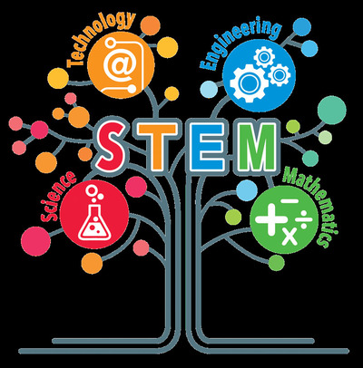 | In this project we will do STEM work with our projects partiners and their students. We know that English is everywhere all STEM materials we can find in english that's why we will use english as generaly language We try daily life problems and he problems of many aspects of the Sustainable Development Goals too. STEM methods is very useful to improve our students many skills it helps develop their future 's carree finding skills too.

